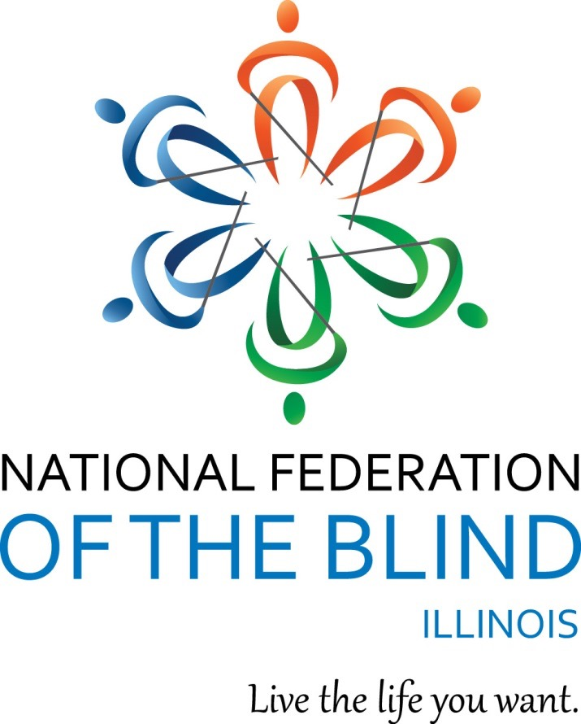

1National Federation of the Blind of Illinois Logo

National Federation of the Blind of Illinois

State Convention 2021

# “STRONGER THAN THE PANDEMIC”

# AGENDA

NATIONAL FEDERATION OF THE BLIND

OF ILLINOIS

Annual Convention

October 22-24, 2021

Sheraton Lisle Naperville Hotel

3000 Warrenville Road

Lisle, IL 60532

630-505-1000

# Members of NFBI wish to thank the following donors for their generous gifts:

The Eileen S. Andrew Foundation

The Gary and Debbie Lindon Family Fund via the Jewish Federation of Metropolitan Chicago

Dr. and Mrs. Neal Hart of the Illinois Prairie Foundation

The Illinois Association of Blind Merchants

The Friends and Family of Cathy Randall for In Memoriam Gifts in honor of her late mother, Cay Barnum

The Friends and Family of T. Doty for In Memoriam Gifts

Mr. Harold W. Knapheide III, in honor of his mother, the late Mary MacDill Knapheide

Community Fun Quad Cities Mildred Crespin-Croegaert

The Naperville Noon Lion’s Club

The Pangere Corporation

Richard Lansden, trustee, The Leona Stanford Vollintine Charitable Trust

# Logistics: Announcements, Registration, Information Desk, and Smoking Policy

Announcements that you wish to be made from the convention floor during sessions MUST be submitted to the information desk in the convention hall. Kira O’Bradovich is coordinating our information desk this year. Michal Nowicki and Patricia Olson are handling the registration table at convention. Mary Grunwald is running our door prize table.

If you wish to reach President Marilyn Green during sessions, please text 312-343-8396.

Smoking is not permitted in convention sessions.

# National Federation of the Blind of Illinois

Marilyn Green, President

5128 N. Oak Park Ave.

Chicago, IL 60656

(312) 343-8396

National Federation of the Blind of Illinois (“NFBI”)

[NFBI Website](http://www.nfbofillinois.org/) www.nfbofillinois.org

[National Federation of the Blind Website](https://nfb.org/) www.nfb.org

# 2021 Sheraton Lisle Naperville Hotel Information

Here is some basic information about our convention hotel, the Sheraton Lisle Naperville.

Address and Phone: The hotel is located at 3000 Warrenville Road, Lisle, IL, 60532. The phone number is 630-505-1000.

The Sheraton Lisle Naperville Hotel, the site of our 2021 state convention, is conveniently located near the Lisle Metra station. It is within five miles of the Morton Arboretum, the Downers Grove Golf Club and the Naperville Riverwalk. The hotel is an 8-story full-service facility with 25,795 square feet of function space.

The rooms are standard size, king bed or two queen beds. To enter your room, you will place your keycard in front of the circular tab above the door handle. All rooms have a coffee maker, hair dryer and a television. There is complementary Wi-Fi in the guest rooms, the common areas and the meeting rooms. The room rate is $99 per night plus applicable taxes. Check-in is 3:00 pm and checkout is 12:00 pm. You need to register for your hotel room by September 30, 2021.

The hotel is smoke free. There is a complementary shuttle that will provide limited service to and from the Lisle Metra station. Stay tuned for information about the shuttle schedule. Hotel parking is complimentary at the Sheraton Lisle Naperville Hotel.

Two sets of automatic doors lead you into the hotel lobby. To the left, at 9 o’clock is the front desk to check in to the hotel. There is an alcove off to the northwest of the front desk that is open 24 hours for snacks. You can pay for them at the front desk. There is a hotel restaurant, which serves breakfast and dinner. It is to the northeast, as you enter the hotel lobby…cross the perpendicular tile to enter the restaurant. The restaurant is open Thursday-Sunday, 7:00-10:00am and 4:00-11:00pm.

With the front desk to your left, proceed down the hallway, off to the right is a set of three elevators that take you to the sleeping rooms. When you get off the elevator at the main level, make a right turn and then shoreline left until you reach an opening…down this hallway, the bathrooms are to the left, the women’s bathroom is first and then the men’s. As you walk past the bathrooms the wall will turn to the left and the restaurant will be directly across from you. If you follow the wall to the left, you will find the breakout meeting room, Shaw is first and further down is Getz. There are large Braille signs outside of each meeting room.

General session, banquet and other activities will be held in the Savoy Ballroom on the main level. Registration will be in the foyer outside the Ballroom. To reach the ballroom, place the restaurant to your left and follow this path to the end. As you get closer to the ballroom, a set of bathrooms will be to your right. The women’s first, followed by the men’s. The guide dog relief area is to the left of the entrance to the Savoy Ballroom. Around the corner is a median with greenery to be used for dog relief. The Scholarship Dinner will be in Private Dining 2. To reach Private Dining 2, place the restaurant to your right and follow this path as it curves to the right. Walk past the restaurant and trail the wall on your right and it will make a sharp right turn. Once you make that turn, Private Dining 2 will be the second large room to your right.

# Braille is Beautiful - Sunday

Braille is Beautiful will take place on Sunday morning, October 24. Please feel free to reach out to Deborah Stein if you wish to participate. Her e-mail address is [dkent5817@att.net](mailto:dkent5817@att.net), and her phone is 773-203-1394.

# IABS, INFORMATION, PAC AND SALES TABLES

The information desk will be in the hotel main lobby on Friday October 22, from 2:00 to 4:30 p.m., and in our general session room during general sessions. Registration will be in the hallway outside of the Savoy Ballroom on Friday from 4:00 through 7:00 p.m. as well as on Saturday from 8:00 to 9:00 a.m. The sales table for IABS and NFBI will be in the back during general sessions. The PAC plan table will also be in the back during general sessions.

# Announcement:

You can help build a future of opportunity for the blind by becoming a member of our Dream Makers Circle. Your legacy gift to the National Federation of the Blind or the National Federation of the Blind of Illinois can be made in the form of a will, or living trust, an income generating gift, or by naming us as the beneficiary of a life insurance policy. For additional information, please contact Patti Chang at (773) 307-6440 or at pchang@nfb.org.

The PAC Plan allows members, affiliates, chapters, and others to give a regular and automatic donation to the Federation every month. All you need to provide is your checking or savings account identification information. Because of the costs associated with operating the program, the minimum donation is $5 a month and there is no restriction on how much you donate.

Please sign up at the PAC table during convention to begin a new PAC contribution or to make changes to your current contribution. Your donation will help the blind live the lives they want.

# IABS Fundraiser

IABS Pie Palooza- the Illinois Association of Blind Students wants to have some fun by throwing a pie at affiliate leaders! All monies will go to help IABS. So please be generous. The coordinator of this event is Sara Luna, IABS 1st Vice President.

**Welcome to the 2021 Convention of the National Federation of the Blind of Illinois**

# Friday, October 22, Afternoon

1:30-3:30 Sculpting with Clay – Ralph Cossentino, Instructor of Figurative Sculpture at the Palette and Chisel in Chicago, Savoy Ballroom

2:00-4:30 Information Table – Kira O’Bradovich, Hotel Lobby

4:00-4:50 Resolutions ­– Michal Nowicki and Dustin Cather, Co-chairs, Savoy Ballroom

4:00-7:00 Registration – Pat Olson, Coordinator and Michal Nowicki, Treasurer, Hallway outside of Savoy Ballroom

# Friday, October 22, Evening

5:00-7:00 Scholarship Dinner – (Finalists, Committee Members, and Invited Guests, Private Dining 2)

7:00-11:00 IABS IDOL - Admission $5, includes your first performance

Ellen Bartelt, President, Illinois Association of Blind Students, Savoy Ballroom

Join us for the Illinois Association of Blind Students IABS Idol

Based on the popular TV show, American Idol. IABS Idol invites everyone to participate as a soloist or group and perform a song of their choice. Bring an instrument and perform your favorite song. Each performance costs $5 per person. Don't forget our “Battle of the Chapters.” This year's theme is “Fight songs.”

# Saturday, October 23, Morning

## Parent and Student Breakfast

Savoy Ballroom

7:00-7:10 Introductions

7:10-7:30 Breakfast Served

7:30-7:45 Advocate for Yourself and Your Student - Anil Lewis, Executive Director of Blindness Initiatives, National Federation of the Blind

7:45-8:00 Self-Advocacy on the College Campus– Esli Ramos, Senior, Joliet Community College, Joliet, Illinois

8:00-8:15 STEM-ing into a Strong Advocate – Kinshuk Tella, NABS board member; Junior, Miami University, Oxford, Ohio

## 8:00-9:00 Registration Michal Nowicki, Pat Olson and Dustin Cather

Hallway Outside of Savoy Ballroom

For later registration, please see Michal Nowicki during general sessions.

October 23, 2021 Morning continued

## 9:00-11:30 General Session

Savoy Ballroom

9:00-9:10 Welcome and Announcements – Marilyn Green, President National Federation of the Blind of Illinois

Pledge of Allegiance

Moment of Silence

Joan Porter – August 20, 1939 - April 14, 2021, Chicago

9:10-9:40 National Report – Anil Lewis, National Representative of the National Federation of the Blind and Executive Director of Blindness Initiatives, National Federation of the Blind

9:40-9:55 National Students Report – Kinshuk Tella, Student Representative and Board of Directors of the National Association of Blind Students, a Division of the National Federation of the Blind

9:55-10:05 My Internship: A Step toward Getting My First Job – Sara Luna, 1st Vice President, Illinois Association of Blind Students

10:05-10:35 Business Owner Panel: What Success Looks Like –

Steve Pangere, owner of Pangere Construction, Ken Coleman, owner of Onnie Music, and Sabrina Simmons, owner of Eye Learn

10:35-10:55 Let’s Read Together -Joe Natale, Chief Deputy Director, Illinois State Library

10:55-11:15 Eligibility and Accessing Blindness Services from the Illinois Bureau of Blind Services – Ingrid Halvorsen, Assistant Bureau Chief, Illinois Bureau of Blind Services

11:15-11:30 I Mark the Spot – Rudy Houston, Student, Springfield, Illinois and John Hill, Springfield, Illinois

11:30-12:00pm Break

## 12:00 pm-1:45pm Student/Parent lunch – Savoy Ballroom

12:00-12:15 Lunch

12:15-12:30 Teaching Excellence Award – Ellen Bartelt, President, Illinois Association of Blind Students

12:30-12:45 2021 Scholarship Finalists – Deborah Stein and Patti Chang, Scholarship Co-chairs, National Federation of the Blind of Illinois

12:45-1:05 My Summer in NFB EQ - Dr. Natalie Shaheen, National Center for Blind Youth in Science Project Director, Bloomington, IL and the NFB EQ students

1:05-1:20 Growing with the Federation – Kinshuk Tella, Board member, National Association of Blind Students

1:20-1:45 Table Topics - Working together as a team – Illinois Association of Blind Students

# October 23, 2021 Afternoon

## Breakouts 2:00-3:15 pm

**2:00-3:15 Parent Breakout**

Shaw

2:00-2:30 The Wonderful World of Access Technology

2:30-2:50 Getting the Devices Your Child Needs: Becoming Your Child’s Advocate – Jennifer Howe, Parent, St. Charles, IL and Nelly Gamino, Parent, Berwyn, IL

2:50-3:00 If Only They Had Known: Raising a Child with Low Vision – Cathy Randall, Jacksonville, IL

**Breakout 2**

Getz

2:00-3:15 Advanced Blindness Training at NFB Training Centers – Pam Allen, Executive Director, Louisiana Center for the Blind; Jennifer Kennedy, Executive Director, Blind Inc; Julie Deden, Executive Director, Colorado Center for the Blind

# October 23, 2021, Afternoon continued

## 3:30-5:00 General Session

Savoy Ballroom

3:30-4:00 The Lived Experience of a Person with Multiple Disabilities – Doula Jarboe, President, Colorado Association of the Blind, Hard of Hearing and Deafblind; Denver, Colorado

4:05-4:10 Midwest Student Spring Seminar – Ellen Bartelt, President, Illinois Association of Blind Students

4:10-4:15 2022 NFB State and National Scholarship Programs – Deborah Stein and Patti Gregory Chang, Co-chairs Scholarship committee, National Federation of the Blind of Illinois

4:15-4:20 Nationwide Braille Readers Are Leaders – Deborah Stein, Secretary, National Federation of the Blind of Illinois

4:20-4:30 Washington Seminar 2022 and the NFB Legislative Initiatives – Denise Avant and Dustin Cather, Federal Legislation Co-chairs, National Federation of the Blind of Illinois

4:30-4:40 Ways to Support the NFB – Patti Chang, Director of Outreach, National Federation of the Blind and National Federation of the Blind of Illinois 2nd Vice President

4:40-5:00 Braille Enrichment Literacy and Learning (BELL) – Deborah Kent Stein, Illinois BELL Coordinator & Secretary, National Federation of the Blind of Illinois and the BELL Kids

5:00 Adjourn

# Saturday, October 23, Evening

## 5:20-5:50 Scholarship Committee Meeting – President’s Room

## 6:00-7:00 Hospitality – Fourier Outside of Savoy Ballroom

## 7:00 Annual Banquet -Savoy Ballroom

MC – Denise Avant, 1st Vice President

National Federation of the Blind of Illinois

7:05-7:10 Welcome and Invocation – David Meyer, Board Member, National Federation of the Blind of Illinois, Chicago chapter

7:10-7:15 IABS Pie Palooza – Ellen Bartelt, President, Illinois Association of Blind Students

7:15-7:25 Freedom Link Presentation – Deborah Stein Secretary, National Federation of the Blind of Illinois

7:25-7:55 Dinner

7:55-8:15 NFBI Covid Relief Grant Program – Patti Chang, 2nd Vice President

Presentation from grant recipients

8:15-8:30 Fifteen for Funds – Cathy Randall, Board member, National Federation of the Blind of Illinois

8:30-8:50 Banquet Speech – Anil Lewis, NFB National Representative

8:50-9:00 Scholarship Awards – Deborah Kent Stein and Patti Chang, Scholarship Co-chairs, National Federation of the Blind of Illinois

9:00 Adjourned

## 9:00-11:00 Hospitality

# Sunday, October 24, 2021,

Savoy Ballroom

## 7:00-8:30am Illinois Association of Blind Students Breakfast and Business Meeting

IABS President, Ellen Bartelt

Note: All are welcome who are interested in student issues but please note that only those who have paid IABS dues may vote in elections. Please see Glenn Moore or any IABS Board Member to pay dues. We will be collecting money at the registration table and at the IABS table during convention.

7:00-7:30 Breakfast

7:30-7:35 Treasurer’s Report - Glenn Moore, Illinois Association of Blind Students Treasurer

7:35-7:45 Presidents Report – Ellen Bartelt, President, Illinois Association of Blind Students

7:45-8:00 Elections

Secretary position currently held by Sabrina Kimbrough

General Board Seat 8 currently held by Ayoub Zurikat

General Board Seat 9 Currently Held by Alex Gamino

8:00-8:10 Old Business

New Business

8:10-8:15 Illinois Association of Blind Students Board of Directors Photo Op

8:15 Meeting Adjourned

# October 24, 2021 Morning continued

# 9:00-12:00 General Session

Savoy Ballroom

9:00-9:05 Call to Order

9:05-9:30 Braille Is Beautiful: A Dramatic Reading - Deborah Stein, Author and Secretary, National Federation of the Blind of Illinois

9:30-9:40 Closing Remarks – Kinshuk Tella, NABS Student Representative

9:40-9:50 Closing Remarks – Anil Lewis, NFB National Representative

9:50-10:30 State Reports

Treasury Report – Michal Nowicki, Treasurer, National Federation of the Blind of Illinois

Presidents Report – Marilyn Green, President, National Federation of the Blind of Illinois

10:30-11:00 Chapter Reports

Illinois Association of Blind Merchants – Ed Birmingham

Illinois Association of Blind Students – Ellen Bartelt

Chicago Chapter – Denise Avant

At Large Chapter – David Meyer

Blackhawk Chapter – Jean Raushenbach

Four Rivers Chapter – Brian Sumner

11:00-11:30 Resolutions – Michal Nowicki and Dustin Cather, Co-chairs

11:30-12:00 Elections

General Board Seats

Board Seat 1 Currently Held by Bill Reif

Board Seat 2 Currently Held by Mary Grunwald

Board Seat 3 Currently held by Steve Hastalis

Board Seat 4 Currently Held by Dustin Cather

12:00 Adjourned

# Thank You for All You Do

Thanks to the Special Events Committee, the Sound committee, and all others who have served on committees, worked registration and information tables, secured door prizes, and appeared on the agenda. You have helped make this convention a tremendous success.

# NFB PLEDGE

I pledge to participate actively in the efforts of the National Federation of the Blind to achieve equality, opportunity, and security for the blind; to support the policies and programs of the Federation; and to abide by its constitution.

# One-Minute Message

The National Federation of the Blind knows that blindness is not the characteristic that defines you or your future. Every day we raise the expectations of blind people because low expectations create obstacles between blind people and our dreams. You can live the life you want; blindness is not what holds you back.