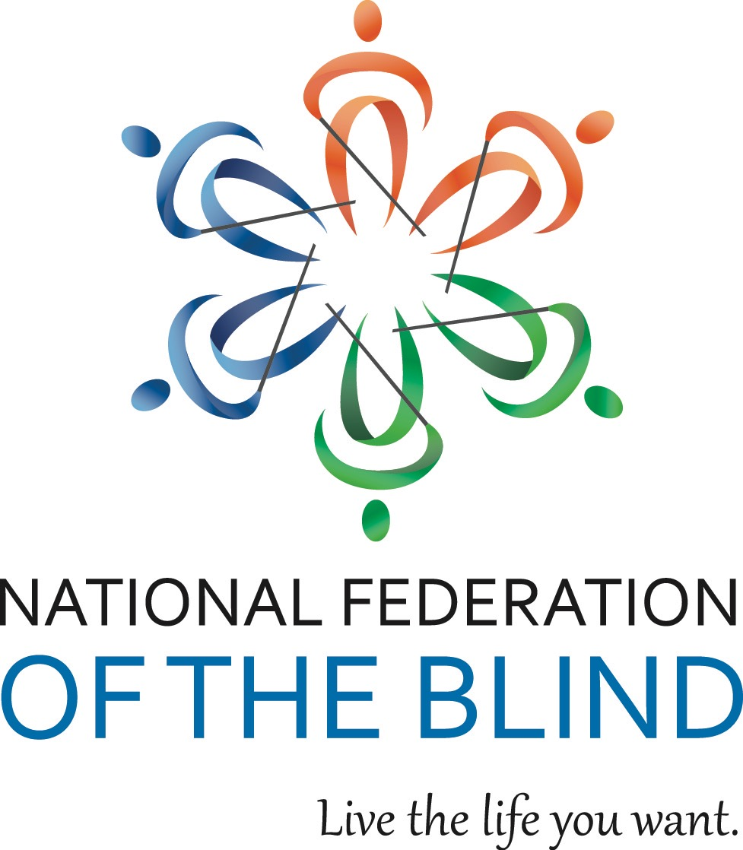

NATIONAL FEDERATION OF THE BLIND OF ILLINOIS

2018 CONVENTION BULLETIN

“COMMEMORATING THE PAST, BUILDING THE FUTURE”

On October 26, 27, and 28 ,2018, enthusiastic Federationists will assemble in Rosemont to celebrate fifty years as a proud affiliate of the National Federation of the Blind and to renew our dedication in the pursuit of security, equality, and opportunity for all blind people. This year’s convention is significant because it is being held concurrently with the conference of the Illinois Committee of Blind Vendors, October 25, 26, and 27.

The site for our convention will be the Sheraton Chicago O’Hare, 6501 N. Mannheim Road, Rosemont, Il 60018. Phone: 847-699-6300. Room rates are $99 per night plus applicable taxes. Please indicate that you are with the NFBI to get this special rate. Make reservations by calling 888-627-8117. Reservations must be guaranteed with a credit card or a one-night deposit. Our cutoff date for reservations is October 5.

This year’s convention will kick off on Friday with our resolutions committee meeting. Come learn and participate in our governing process. The Resolutions Committee will be chaired by Steve Hastalis. ALL resolutions must be submitted by October 12, 2018. Steve may be contacted at 773-848-5307 or e-mail at

[Steve.hastalis@gmail.com](mailto:Steve.hastalis@gmail.com).

IABS IDOL will occur Friday evening. Those wanting to perform during the IABS Idol should contact IABS by e-mailing Adrienne Falconer at [afalc2@gmail.com](mailto:afalc2@gmail.com). Please put IABS IDOL in your subject line. The fee for this event is $5, and includes your first performance. Every performance thereafter will be $5.

Our general session will convene on Saturday, October 27, at 9 a.m. During Saturday’s general sessions we will hear a National Report regarding NFB happenings delivered by Jeannie Massay, treasurer of the National Federation of the Blind and president of the National Federation of the Blind of Oklahoma. Her bio can be found at https://nfb.org. We will have a presentation by Ramona Walhof, (Idaho), Mary Grunwald and Leslie Hamric celebrating the forming of our affiliate, and the impact on the lives of blind people in Illinois. We will also hear from Luke Miller, a participant in our internship program, along with presentations on Illinois’ Braille Enrichment Literacy and Learning Programs, Blind Inc Participants, and employment. We will also be joined by Ingrid Halvorsen, Assistant Bureau Chief of the Illinois Bureau of Blind Services, who will talk about the services for the blind in our state. You will hear from Ray Campbell, Senior Accessibility Analyst at United Airlines. You will hear from Kenia Flores board member of the National Association of Blind Students and a 2018 NFB scholarship winner, and much much more.

We will have a Saturday parent breakfast and a Sunday student breakfast. We will have a combined vendor and student/ parent lunch on Saturday. In addition, there will be a breakout session for parents of blind children.

Saturday evening will culminate with our annual banquet, featuring an inspiring address from our National Representative, Jeannie Massay. We will also see the much-anticipated scholarship awards.

Sunday morning’s general session will begin with Braille is Beautiful and we will hear from other blind people sharing their experiences. Resolutions will be voted on during the Sunday morning session. Adjournment is scheduled for 12:00 p.m. on October 28.

Advance registration for the convention made before October 12 is $5. Registration after that date or at convention will be $20. You can register and pay online at [www.nfbofillinois.org](http://www.nfbofillinois.org). If you need assistance with filling out the online form, please call Patti Chang at 773-307-6440 or David Meyer at 708-606-7091 to assist with the online registration process. If you are mailing your form and payment, the registration form and fees for breakfasts, luncheon, and banquet should be sent before October 12 to Patti Chang, Treasurer NFBI 6919 W. Berwyn Ave. 60656, make checks payable to NFB of Illinois. Please do not send cash.

We will host a meeting for parents of blind children at 7 a.m. on Saturday. The student business meeting will be held on Sunday morning at 7:00 a.m. These are both breakfast meetings.

Each breakfast cost $10. Saturday’s combined vendor and student/parent lunch cost is $20. The banquet on Saturday night will start at 7 p.m. and tickets will cost $30.

Those with special dietary needs for any of the meals should contact Patti Chang, 773-307-6440 or [pattischang@gmail.com](mailto:pattischang@gmail.com). The deadline for such requests is October 21. Please do not contact the hotel regarding any meal needs.

Kids’ Kamp (childcare) will be available on Saturday from 8:30 a.m. to 5:30 p.m. Kids’ Kamp is free to all children ages 3 to 12 who are registered for the convention. A separate release form must be filled out at time of registration.

Federation conventions change the lives of blind and sighted people alike! Don’t miss out on this opportunity for change! Join us for our best convention yet! Come and live the life you want!!!