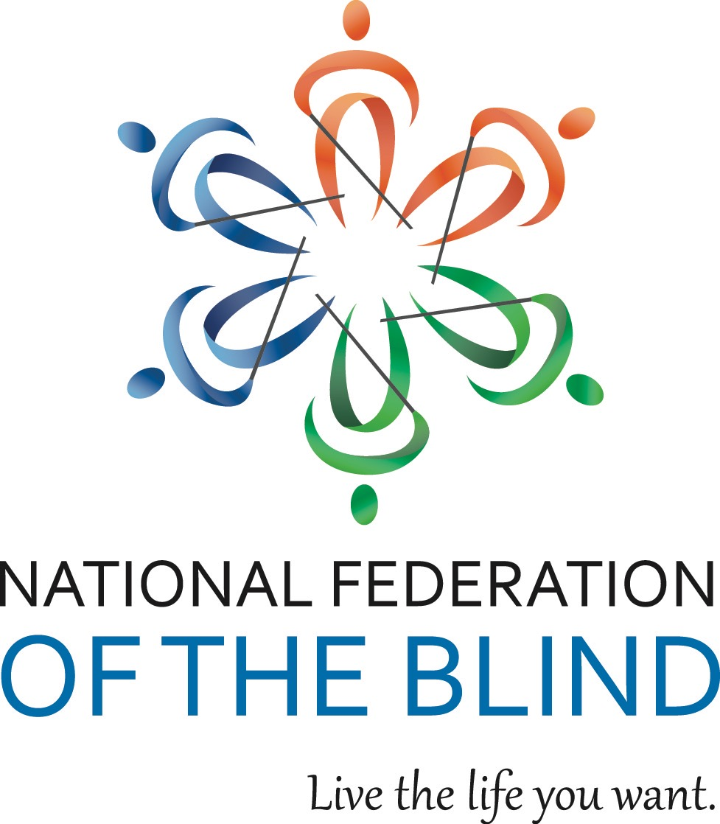

NATIONAL FEDERATION OF THE BLIND OF ILLINOIS

2017 CONVENTION BULLETIN

“STEPPING OUT WITH AUTHORITY”

On October 27, 28, and 29,2017, enthusiastic Federationists will assemble in Naperville to renew our dedication in the pursuit of security, equality, and opportunity for all blind people.

The site for our convention will be the Chicago Naperville Marriott, 1801 Naper Blvd., Naperville, IL 60563 phone (630) 505-4900. Room rates are $104 per night plus applicable taxes. Please indicate that you are with the NFBI to get this special rate. Make reservations by calling (800) 228-9290. Reservations must be guaranteed with a credit card or a one night deposit. Our cutoff date for reservations is October 6.

This year’s convention will kick off on Friday with our resolutions committee meeting. Come learn and participate in our governing process.

The Resolutions Committee will be chaired by Patti Chang. ALL resolutions must be submitted by October 13, 2017. She may be contacted at (773) 307-6440 or e-mail at [pattischang@gmail.com](mailto:pattischang@gmail.com).

IABS IDOL will occur Friday evening. Those wanting to perform during the IABS Idol should contact IABS by e-mailing Adrienne Falconer at [afalc2@gmail.com](mailto:afalc2@gmail.com). Please put IABS IDOL in your subject line.

Our general session will convene on Saturday, October 28, at 9 a.m. During Saturday’s general sessions we will hear a National Report regarding NFB happenings delivered by our National Representative, President Mark Riccobono. His bio can be found at https://nfb.org. We will hear presentations on the blind vendor program from Giovanni Francese, Vice Chairman of the Illinois Committee of Blind Vendors, parental rights from Paul Rink, Director of the Cane Legal Clinic, and the tollway project from Dr. Janet Szlyk, President and CEO of the Chicago Lighthouse. We will also be joined by Quinetta Wade, Director of the Department of Rehabilitation Services, who will talk about the services for the blind in our state and Martin Wild from Arts International. Patti Chang, Illinois Liaison for the KNFB Reader, and NFBI board member Bill Reif, will talk about and demonstrate the KNFB Reader for Windows . You can learn about the latest technology from Mike Mingson of AIRA. We will have a presentation on audio described plays, hear from our national representative from the National Association of Blind Students, and much more.

We will have a Saturday parent breakfast and a Sunday student breakfast. We will have both student and parent luncheons on Saturday. In addition, there will be a breakout session for parents of blind children.

Saturday evening will culminate with our annual banquet, featuring an inspiring address from our National Representative, our National President, Mark Riccobono. We will also see the much-anticipated scholarship awards.

Sunday morning’s general session will begin with Braille is Beautiful and we will hear from other blind people sharing their experiences. Resolutions will be voted on during the Sunday morning session. Adjournment is scheduled for 12:00 p.m. on October 29.

Advance registration for the convention made before October 13 is $5. Registration after that date or at convention will be $15. This year you can register and pay online at [www.nfbofillinois.org](http://www.nfbofillinois.org). If you are mailing your form and payment, the registration form and fees for breakfasts, luncheon, and banquet should be sent before October 13 to Patti Chang, Treasurer NFBI 6919 W. Berwyn Ave. 60656, made payable to NFB of Illinois. Please do not send cash.

We will host a meeting for parents of blind children at 7 a.m. on Saturday. The student business meeting will be held on Sunday morning at 7:00 a.m. These are both breakfast meetings.

Two breakfasts are planned. Their cost is $10. We will have two luncheons for all those interested in student and/or parent issues on Saturday. The cost for either luncheon will be $15. The banquet on Saturday night will start at 7 p.m. and tickets will cost $30.

Those with special dietary needs for any of the meals should contact Patti Chang, (773) 307-6440 or [pattischang@gmail.com](mailto:pattischang@gmail.com). The deadline for such requests is October 13.

Kids’ Kamp (childcare) will be available on Saturday from 8:30 a.m. to 5:30 p.m. Kids’ Kamp is free to all children ages 3 to 12 who are registered for the convention. A separate release form must be filled out at time of registration.

Federation conventions change the lives of blind and sighted people alike! Don’t miss out on this opportunity for change! Join us for our best convention yet! Come and live the life you want!!!