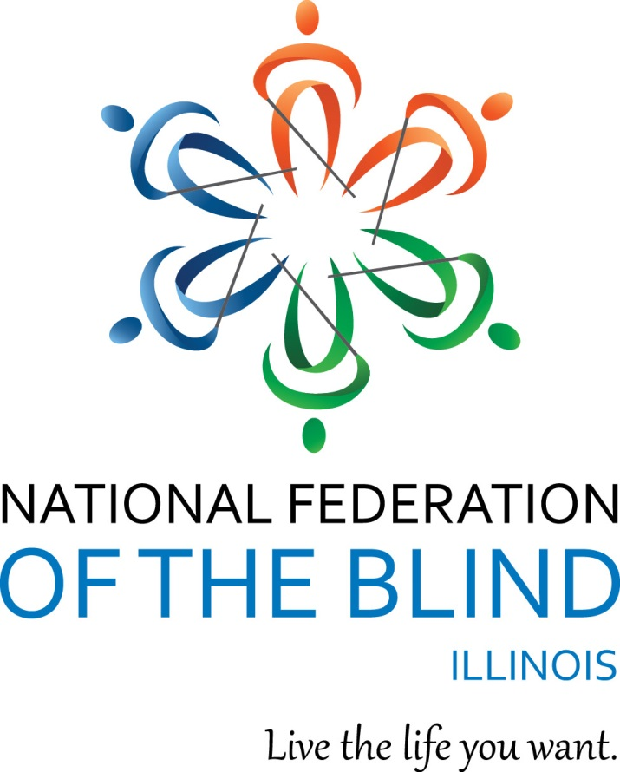

National Federation of the Blind of Illinois

State Convention 2017

“Stepping Out With Authority”

AGENDA

NATIONAL FEDERATION OF THE BLIND

OF ILLINOIS

Annual Convention

October 27-29, 2017

Naperville Marriott

1801 Naper Blvd

Naperville, IL 60563

630 505-4900

[Naperville Marriott Website](http://www.marriott.com/hotels/travel/chimn-chicago-marriott-naperville/)

Members of NFBI wish to thank the following donors for their generous gifts:

Advanced Group

The Aileen S. Andrew Foundation

Jefferson L. Miller, Jr. and Abby Lock Castle

J. Milton Harris/and Alice Chenault

Dr. and Mrs. Neal Hart of the Illinois Prairie Foundation

The Illinois Association of Blind Merchants

Community Foundation Great River Bend - Mildred Crespin-Croegaert Fund

Mr. Harold W. Knapheide III, in honor of his mother, the late Mary MacDill Knapheide

Elick and Charlotte Lindon Foundation

The Community Foundation of the Quincy Area from the Arthur O. and Lela B. Lindsey Fund

The Naperville Noon Lion's Club

NFB Jacob Bolotin Fund

Trinity Fellowship

Richard Lansden, trustee, The Leona Stanford Vollintine Charitable Trust

Samuel Weinstein Family Foundation

Announcements that you wish to be made from the convention floor during sessions MUST be submitted to the information desk in the convention hall. Mary Grunwald and Roberta Reif are coordinating our information desk this year. Patricia Olson is handling registration table at convention. Mary Grunwald is running our door prize table.

If you wish to reach President Denise R. Avant during sessions, please convey your requests to the information desk.

Smoking is not permitted in convention sessions.

National Federation of the Blind of Illinois

Denise R. Avant, President

3410 N. Lake Shore Dr., Apt. 4L-M

Chicago, IL 60657 (773) 991-8050

National Federation of the Blind of Illinois (“NFBI”)

[NFBI Website](http://www.nfbofillinois.org)

[National Federation of the Blind Website](https://nfb.org/free-cane-program)

2017 Naperville Marriott Hotel/Convention Information

[Naperville Marriott Website](http://www.marriott.com/hotels/travel/chimn-chicago-marriott-naperville/)

This quick article explains the layout of the Naperville Marriott which is our convention hotel for 2017. It also gives you basic information about the facilities and amenities.

Address and Phone:

The hotel is located at 1801 N. Naper Blvd Naperville, IL 60563. The phone is: (630) 505-4900.

Sleeping Room Types:

There are two types of rooms. A Suite and a Standard Room. The suites have a parlor with a sleeper sofa and two easy chairs. The room rate for standard rooms is $104. All rooms have hair dryers and coffee makers. Connecting rooms are available upon request.

Keycards and Electrical Power:

This hotel is modernized. You need to insert your keycard in a slot inside your room to the side of the door to turn your power on. Leave it in the slot until you exit your room. When you remove it, the power goes off again.

Checkout:

Check in time is 3:00 p.m. Checkout time is 12:00 p.m.

Wi Fi:

There is free Wi Fi in all lobby and common areas. This includes our meeting rooms.

Facilities:

There is an indoor pool, fitness room, and Jacuzzi. There is lots of parking especially by the side door.

Shuttles:

The hotel runs free shuttles within a five mile radius. Since there are trains scheduled to leave at 12:30, 2:30, and 4:30 headed for downtown Chicago, we will make every effort to complete the convention by noon on Sunday.

The hotel also has a contract with a limo company which provides discounted service to and from each airport. The cost is under $40 which compares favorably to a cab which would be $65 or so.

Layout:

If you enter through the main doors, the layout is as follows: the Starbucks is to the left. You should walk ahead to where the tiled flooring forms a cross. If you turn left at the "lobby cross" with the doors at your back, you can enter Starbucks by taking the first left. If you take a right, you can go to the elevator bank. If you pass the elevators, you head toward the meeting rooms.

From the front door, if you simply bypass the crossing of the tiled portions of the lobby and keep going straight, you will find our information desk on your left and the hotel desk on your right. If you pass both, there is a restaurant directly ahead. You can find the bar which also serves food from the restaurant by going left after passing the hotel desk. The bar will be on your right although people can also sit on the left side at this point in the lobby.

If you reorient to the lobby desk, at this point it is easier. If you are standing facing the hotel front desk, the elevator bank is down the tiled hall to the right of the front desk. There are three elevators on your left side down that hall a short way. They are fast.

Our meeting rooms are laid out past the elevator bank. Right after the elevators there is a cash machine on your left and restrooms on your right. Past those, first you come to a hallway where conference rooms A, B, and C are on your left headed away from the lobby. Conference rooms D, E, and F are on your right. Past that Hall the hall divides at a Y. There is another set of restrooms down by the other conference rooms near Bailey. If you go left, you come to Bailey-Hobson and if you go right you will get to the Naper room. We are in Naper 2 and 3 on Friday, October 27, the banquet on October 28, and for general sessions on Sunday, October 29. Saturday’s general sessions, October 28, will be held in conference room A. Outside of the Naper room we will have exhibits and we will have our registration.

There is a dog relief area outside of the Naper room. Exit and walk a short way, then take a 45 degree left turn. There is a cement patio area on the left about 30 ft. up. At the end of the patio, you will find a grassy area with trees which will work well for dog relief. There is even a hydrant.

Braille is Beautiful - Sunday

Braille is Beautiful will take place on Sunday. Please feel free to reach out to Debbie Stein if you wish to participate.

Set-up for Naper 2 and 3:

When you enter the Naper Room it is wider left to right and shorter going ahead from the doors. You enter at the back of the room. We will have info, sales, and IABS in the back of the room and head table/stage will be furthest from the doors by the windows. Door prize table will be on the right as you face the stage.

Have a great convention, everyone!

IABS, INFORMATION, PAC AND SALES TABLES

The information desk will be in the hotel main lobby on Friday Oct. 27 from 2:00 to 4:30 p.m., and in our general session room during general sessions. Registration will be in the hallway outside of the Naper room on Friday from 4:00 through 7:00 p.m. as well as on Saturday from 8:00 to 9:00 a.m. The sales table for IABS will be in the back during general sessions. The PAC plan table will also be in the back during general sessions. Exhibitors will be outside of our general sessions room.

Announcement:

You can help build a future of opportunity for the blind by becoming a member of our Dream Makers Circle. Your legacy gift to the National Federation of the Blind or the National Federation of the Blind of Illinois can be made in the form of a will, or living trust, an income generating gift, or by naming us as the beneficiary of a life insurance policy. For additional information, please contact Patti Chang at (773) 307-6440 or at pchang@nfb.org.

The PAC Plan allows members, affiliates, chapters, and others to give a regular and automatic donation to the Federation every month. All you need provide is your checking or savings account identification information.

Because of the costs associated with operating the program, the minimum donation is $5 a month and there is no restriction on how much you donate.

Please sign up at the PAC table during convention to begin a new PAC contribution or to make changes to your current contribution. Your donation will help the blind live the lives they want.

IABS Raffle

IABS Raffle- the Illinois Association of Blind Students will hold a raffle with the winner to be drawn at the banquet on Saturday, October 28, 2017. Tickets are $2 or three for $5. All monies will go to help IABS. So please be generous. The coordinator of this event is Emma Meyer, IABS President.

KNFB Reader

The KNFB Reader

Now you can have the convenience of an OCR scanner in the palm of your hand. The KNFB Reader app is a revolutionary tool that you can use, with the touch of a single button, to read virtually any type of printed text, including mail, receipts, class handouts, memos, and many other documents. Accuracy is facilitated by a field-of-view report, automatic page detection, and tilt control.

Proprietary document analysis technology determines the words and reads them aloud to the user with high quality text-to-speech. Read the words you want to read; live the life you want.

Visit the Apple App Store to purchase the KNFB Reader app and start enjoying it today! Now the Reader is available for android and Windows operating systems.

For the latest news and information about the KNFB Reader, follow us on Twitter @KNFBReader or like us on Facebook.

Welcome to our 2017 State Convention of the National Federation of the Blind of Illinois!!!

Friday, October 27, 2017, Afternoon

2:00-4:30 Information Table – Mary Grunewald and Roberta Reif, Hotel Lobby

4:00-7:00 Registration, Pat Olson, Registration Coordinator

Hallway Outside of Naper

4:00-5:00 Resolutions - Patti Chang, Chair NFBI Resolutions Committee

Naper 2 and 3

October 27, 2017, Evening

4:00-7:00 Registration - Pat Olson, Hallway outside of Naper

4:00-7:00 Exhibits - Hallway outside of Naper

E.M. Vitu, Inc

Guide Dogs for the Blind

Vanda Pharmaceuticals, Inc.

5:00-6:00 At Large get-to-know-you Dinner - Chapter President, Linda Hendle

Cost $10, room TBA

5:00-7:00 Scholarship Dinner – (Winners, Committee Members, and Invited Guests)

Conference Room E

700-11:00 IABS IDOL - Admission $5, includes your first performance

Emma Meyer, IABS President, Naper 2 and 3

Join us for the Illinois Association of Blind Students IABS Idol

Based on the popular TV show, American Idol. IABS Idol invites everyone to participate as a soloist or group and perform a song of their choice. Wear a costume and celebrate Halloween, bring an instrument and perform your favorite song. Each performance costs $5 per person. Don't forget our “Battle of the Chapters.” This year's theme is weather related songs.

Saturday, October 28, 2017, Morning

7:30-8:30 Parents Breakfast

Naper 2 and 3

7:30-7:50 Dining Under Sleep Shades, Patti Chang, Esq.

7:50-8:05 Remembering BELL - Amy Lund and BELL Participants

8:05-8:30 On the Job Training: The Adventure of Raising your Blind Child –

Mark A. Riccobono, President, National Federation of the Blind

8:00 - 9:00 Registration

Pat Olson, Registration Coordinator

Outside of Naper Room

Later registration see Patti Gregory Chang in General Sessions

8:00-9:00 Exhibits

Kids Camp Agenda October 28, 2017

8:30-5:30 Kids Camp

Conference Room E

8:45-9:00 Registration ($10/child for lunch)

9:00-9:30 Introductions and ice breaker (stretching)

9:30-10:30 Halloween crafts; snack

10:30-11:00 Halloween stories

11:00-11:30 Treasure hunt

12:00-1:00 Lunch

1:00-2:00 Movie

2:00-3:15 Go ball

3:30-4:00 free time

4:00-4:45 Sing-a-long and music instruments with Dave, Steve and Cathy

4:45-5:00 Wrap up/clean up; pick up time,

October 28, 2017, Morning Sessions

9:00-11:30 General Session

Conference Room A

9:00-9:10 Welcome and Announcements - Denise R. Avant, President NFBI

Pledge of Allegiance

Moment of Silence, Annette R. Grove - February 23, 1939 to May 13, 2017 - Four Rivers Chapter

Donald Gillmore – 1942 September 13, 2017 - Prairie State and Chicago Chapters

Charlotte Lyndon - 1920 to July 18, 2017 - Freedom Link Supporter and Donor - Glenview Illinois

9:10-9:55 National Report - Mark A. Riccobono, President, National Federation of the Blind

9:55-10:05 Remarks - - State Rep. Michael Connelly, R 21st District, Naperville, Illinois

10:05-10:20 National Association of Blind Students Report - Syed Risvi, 2d Vice President, National Association of Blind Students, a division of the NFB

10:20-10:40 Audio Description at the Theater - Martin Wilde, Arts Access International, LLC and Deborah Kent Stein, 1st Vice President NFBI

10:40-11:10 The State of Rehabilitation Services for the Blind of Illinois

Quinnetta Wade, Director of Illinois Department of Rehabilitation Services and John Gordon, chief of Illinois Bureau of Blind Services

11:10-11:30 Consolidation of Talking Book Library Services - Sharon Ruda, Associate Director Illinois State Library

12:00-1:30 Illinois Association of Blind Students lunch and program in conjunction with our parents of blind children group

Conference Room A

Note that our parents group will move to conference room F at the start of their breakout.

12:00-12:30 Presentation of scholarship class

12:30-1:00 Teacher Excellence Awards

1:00-1:30 Student breakout

Remain in Conference Room A

1:00-2:15 Parents Breakout

Conference Room F

1:00-1:25 Introductions: Who We Are and Why We Are Here

1:25-1:35 Visual Interpretation with AIRA, Michael Hingson

1:35-1:45 What I Did Last Summer: Fun and Learning at NFB Youth Slam: Alex Gamino and Kaitlyn Ryan

1:45-2:30 The Courage to Let Go: A Discussion with Patti Chang, Debbie Kent Stein, Melissa Riccobono, and Julieta Meyer

October 28, 2017, Afternoon sessions

2:00-5:00 General Session

Conference Room A

2:00-2:20 Services at the Cane legal Clinic and Parental Rights for the Blind - Paul Rink Director of Cane Legal Clinic, Chicago Lighthouse for People who are blind or Visually Impaired

2:20-2:40 State of the Tollway Project - Dr. Janet P. Szlyk, President and Chief Executive Officer, Chicago Lighthouse for People who are Blind or Visually Impaired

2:40-3:00 Business Opportunities in the Illinois Blind Vending Program - Giovanni Francese, Illinois Committee of Blind Vendors

3:00-3:20 What's New with the KNFB Reader - Patti Chang, Treasurer NFBI and Illinois KNFB Reader Coordinator and Bill Reif, NFBI Board Member

3:40-4:00 Explore Your World with Aira - Michael Hingson, Director of Strategic Sales of Aira

4:00-4:20 Advanced Blindness Skills Training At the NFB Centers – Robert Gardner

4:20-4:30 NFB Legislative Advocacy in Washington – Dustin Cather, Washington Seminar attendee

4:30-4:35 NFBI Internship Program, and NFB National and State Scholarship Programs – Patti Chang, NFB National Scholarship Chair Emeritus

4:35-4:40 Braille Enrichment for Literacy and Learning Academies- Patti Chang, BELL Coordinator

4:40-4:45 Braille Readers Are Leaders – Robert Gardner

4:45-4:50 Braille Literacy: The Life Group – Linda Hendle, At Large Chapter President

4:50-5:00 Get On the PAC Plan – Denise Avant, President, and NFBI

5:00 Adjournment

October 28, 2017, Evening

5:30-6:30 State Scholarship Committee Meeting – Room TBA

6:00-7:00 Hospitality

Naper 2 and 3

7:00-10:00 Annual Banquet

Naper 2 and 3

MC Debbie Stein, 1st Vice President, NFBI

7:05 Welcome and Invocation David Meyer, 2nd Vice President

7:10 Illinois Association of Blind Students Raffle

8:15 Recognition of Blind Educator of the Year Debbie Stein

8:25 Freedom Link Recognition: the Bolotin Award – Denise Avant, President, NFBI, Emma Meyer, IABS President and Amy Bosko, 2d Vice President, IABS

8:35 Awards – Patti Chang and Cathy Randall

8:45 Fifteen for Funds – Cathy Randall, Board Member NFBI

9:00 Banquet Keynote – Mark A. Riccobono, President, National Federation of the Blind

9:45 Presentation of State Scholarships – Debbie Stein, 1st Vice President

10:00-12:00 Hospitality

Naper 2 and 3

Sunday, October 29, 2017

7:00-8:30 IABS Breakfast and business Meeting Emma Meyer, IABS President

Naper 2 and 3

Note: All are welcome who are interested in student issues but please note that only those who have paid IABS dues may vote in elections. Please see Glenn Moore or any IABs Board Member to pay dues. We will be collecting money at the registration table and at the IABS table during convention.

President's, Treasurer's, and Secretary's Reports

Committee Reports

Elections

Board Seat 3, currently held by Alex Gamino

Board Seat 4, currently held by Aziz Zeidieh

Old Business

New Business

Adjournment

Sunday, October 29, 2017

9:00-12:00 General Session

Naper 2 and 3

9:00-9:05 Call to Order

9:05-9:45 Braille Is Beautiful, a Dramatic Reading,

Debra Stein, Author and 1st Vice President, National Federation of the Blind of Illinois

9:45-9:55 Closing Remarks NABS, Syed Risvi, 2d Vice President, National Association of Blind Students

9:55-10:30 Presidents and Treasurers Report

Treasurers Report – Patti Chang, Treasurer NFBI

Presidents Report – Denise Avant, President, NFBI

10:30-11:00 Chapter Reports

Illinois Merchants Division – Ed Birmingham, President, IABM

IABS – Emma Meyer, IABS

At Large Chapter – Linda Hendle, President at Large Chapter

Chicago Chapter – Steve Hastalis, President, Chicago Chapter

Black Hawk Chapter – Patrick Olson, President, Blackhawk Chapter

Four Rivers Chapter - Brian Sumner, President, Four Rivers

Ferris Wheel Chapter – Bill Reif, President Ferris Wheel

11:00-11:30 Resolutions, Chair, Patti Chang

11:30-12:00 Elections

General Board Seat

Board Seat 1, currently held by Bill Reif

Board Seat 2, currently held by Mary Grunwald

Board Seat 3, currently held by Steve Hastalis

Board Seat 4, currently held by Adrienne Falconer

Election of Delegate and Alternates to 2017 National Convention

Final Remarks from National Representative - Mark A. Riccobono, President, NFB

12:00 Adjournment

Thanks to the Special Events Committee, the Sound committee, and all others who have served on committees, worked registration and information tables, secured door prizes, and appeared on the agenda. You have helped make this convention a tremendous success.

NFB of Illinois

President: Denise R. Avant, Esq.

NFB PLEDGE

I pledge to participate actively in the effort of the National Federation of the Blind to achieve equality, opportunity, and security for the blind; to support the policies and programs of the Federation; and to abide by its constitution.

One-Minute Message

The National Federation of the Blind knows that blindness is not the characteristic that defines you or your future. Every day we raise the expectations of blind people because low expectations create obstacles between blind people and our dreams. You can live the life you want; blindness is not what holds you back.