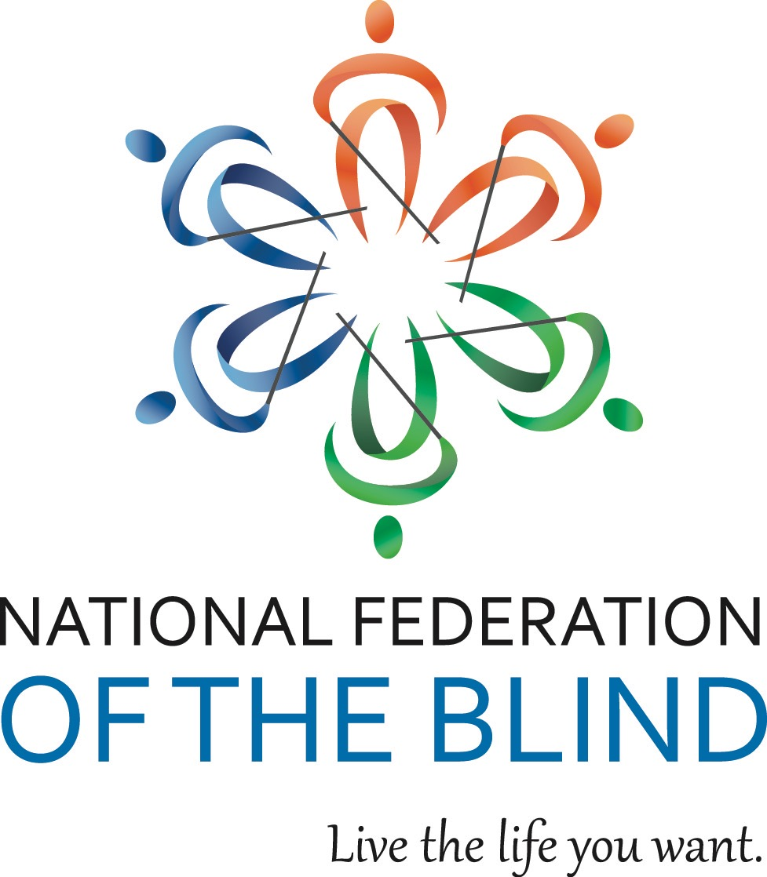

NATIONAL FEDERATION OF THE BLIND OF ILLINOIS

2016 CONVENTION BULLETIN

“CONQUERING THE ODDS”

On October 28th, 29th, and 30th,2016, enthusiastic Federationists will assemble in Naperville to renew our dedication in the pursuit of security, equality, and opportunity for all blind people.

The site for our convention will be the Chicago Naperville Marriott, 1801 Naper Blvd., Naperville, IL 60563 phone (630) 505-4900. Room rates are $104 per night plus applicable taxes. Please indicate that you are with the NFBI to get this special rate. Make reservations by calling (800) 228-9290. Reservations must be guaranteed with a credit card or a one night deposit. Our cutoff date for reservations is October 7th.

This year’s convention will kick off on Friday with our resolutions committee meeting. Come learn and participate in our governing process.

The Resolutions Committee will be chaired by Patti Chang. ALL resolutions must be submitted by October 14th, 2016. She may be contacted at (773) 307-6440 or e-mail at [pattischang@gmail.com](mailto:pattischang@gmail.com).

IABS IDOL will occur Friday evening. Those wanting to perform during the IABS Idol should contact IABS by e-mailing Adrienne Falconer at [afalc2@gmail.com](mailto:afalc2@gmail.com). Please put IABS IDOL in your subject line.

Our general session will convene on Saturday, October 29th, at 9 a.m. During Saturday’s general sessions we will hear a National Report regarding NFB happenings delivered by our National Representative, Mr. Joe Ruffalo, Jr., President of our New Jersey affiliate, and board member of the National Federation Of The Blind. His bio can be found at https://nfb.org. We will hear presentations on careers in investments, as well as information about the Hadley Institute For The Blind, Horizons For The Blind, and 3DPhotoworks. We will also have remarks from Luke Schwinck, treasurer of the National Association Of Blind Students. Peter Tucic of Humanware Inc. will demonstrate its newest notetaker, the Braillenote Touch. We will also hear from John Gordon, chief of the Illinois Bureau Of Blind Services. There will be a short dance demonstration by Francisco and Patti Chang. Plus, we will also hear from our Freedom Link and BELL participants just to name a few of our agenda items.

We will have a Saturday parent breakfast and a Sunday student breakfast. We will have both student and parent luncheons on Saturday. In addition, there will be a breakout session for parents of blind children.

Saturday evening will culminate with our annual banquet, featuring an inspiring address from our National Representative, Mr. Joe Ruffalo, Jr. We will also see the much-anticipated scholarship awards.

Sunday morning’s general session will begin with Braille is Beautiful and we will hear from other blind people sharing their experiences. Resolutions will be voted on during the Sunday morning session. Adjournment is scheduled for 12:00 p.m. on October 30th.

Advance registration for the convention made before October 14th is $5. Registration after that date or at convention will be $15. This year you can register and pay online at [www.nfbofillinois.org](http://www.nfbofillinois.org). If you are mailing your form and payment, the registration form and fees for breakfasts, luncheon, and banquet should be sent before October 16th to Patti Chang, Treasurer NFBI 6919 W. Berwyn Ave. 60656, made payable to NFB of Illinois. Please do not send cash.

We will host a meeting for parents of blind children at 7 a.m. on Saturday. The student business meeting will be held on Sunday morning at 7:00 a.m. These are both breakfast meetings.

Two breakfasts are planned. Their cost is $10. We will have two luncheons for all those interested in student and/or parent issues on Saturday. The cost for either luncheon will be $15. The banquet on Saturday night will start at 7 p.m. and tickets will cost $30.

Those with special dietary needs for any of the meals should contact Patti Chang, (773) 307-6440 or [pattischang@gmail.com](mailto:pattischang@gmail.com). The deadline for such requests is October 14th.

Kids’ Kamp (childcare) will be available on Saturday from 8:30 a.m. to 5:30 p.m. Kids’ Kamp is free to all children ages 3 to 12 who are registered for the convention. A separate release form must be filled out at time of registration.

For those needing financial assistance to attend the convention, all applications must be submitted to President Denise Avant no later than September 1st, 2016 at 3410 N. Lake Shore Dr. Apt. 4L-M, Chicago, Il. 60657 or e-mail [davant1958@gmail.com](mailto:davant1958@gmail.com). The form to fill out for financial assistance from the James Chappell and Carmen Dennis Memorial Fund is available on our web site at [www.nfbofillinois.org](http://www.nfbofillinois.org) or one will be mailed to you upon request.

Federation conventions change the lives of blind and sighted people alike! Don’t miss out on this opportunity for change! Join us for our best convention yet! Come and live the life you want!!!