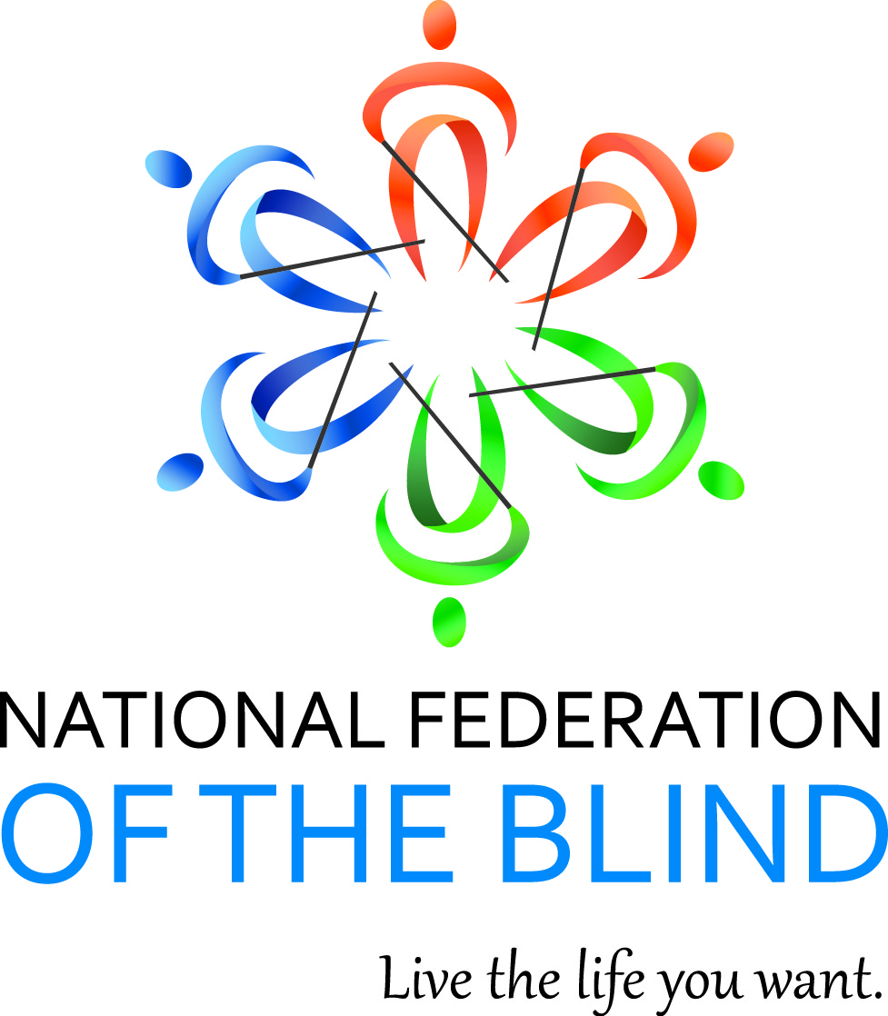

NATIONAL FEDERATION OF THE BLIND OF ILLINOIS
2014 CONVENTION BULLETIN

“CREATE THE LIFE YOU WANT”

On October 31st, Nov. 1^{st,} and 2nd 2014, enthusiastic Federationists will assemble in Naperville to renew our dedication in the pursuit of security, equality, and opportunity for all blind people.

The site for our convention will be the Naperville Marriott, 1801 Naperville Blvd., Naperville, IL 60563 (630) 505-4900. Room rates are $89 per night plus applicable taxes. Please indicate that you are with the NFBI to get this special rate. Make reservations by calling (800) 228-9290. Reservations must be guaranteed with a credit card or a one night deposit. Our cutoff date for reservations is October 10th.

This year’s convention will kick off with Friday afternoon seminars as well as an afternoon resolutions committee meeting. Come learn and participate in our governing process.

The Resolutions Committee will be chaired by Chris Jeckel. ALL resolutions must be submitted by October 15th, 2014. He may be contacted at (217) 369-2915 or at jeckel.chris@gmail.com.

IABS IDOL will occur Friday evening. Those wanting to perform during the IABS Idol should contact IABS by e-mailing Julia Chang at roseailuj@att.net. Please put IABS IDOL in your subject line.

Our general session will convene on Saturday, November 1st at 9 a.m. During Saturday’s general sessions we will hear a National Report regarding NFB happenings delivered by our National Representative, Ms. Ever Lee Hairston, a member of NFB Board of Directors. We will hear from employment and community service panels as well as Janet Szlyk who will talk about the Lighthouse for the Blind and the tollway. We will welcome our Freedom Link and BELL participants just to name a few of our agenda items.

We will have a Saturday parent breakfast and a Sunday student breakfast. We will have both student and parent luncheons on Saturday. In addition, there will be breakout sessions for parents of blind children, a teen scene and significant others meeting.

Saturday evening will culminate with our annual banquet, featuring an energizing address from our National Representative, Ms. Ever Lee Hairston. See: https://nfb.org/ever-lee-hairston-bio. We will also see the much-anticipated scholarship awards.

Sunday morning’s general session will begin with Braille is Beautiful and we will hear from other blind people sharing their experiences. Resolutions will be voted on during the Sunday morning session. Adjournment is scheduled for 12:00 PM on November 2nd.

Advance registration for the convention made before October 15th is $5. Registration after that date or at convention will be $15. This year you can register and pay online at www.nfbofillinois.org. If you are mailing your form and payment, the registration form and fees for breakfasts, luncheon, and banquet should be sent before October 15th to Glenn Moore, Treasurer NFBI, P.O. Box 1065, Elgin, IL 60121. Checks or money orders should be made payable to NFB of Illinois. Please do not send cash.

We will host a meeting for parents of blind children at 7 a.m. on Saturday. The student business meeting will be held on Sunday morning at 7:00 a.m. These are both breakfast meetings.

Two breakfasts are planned. Their cost is $10. We will have two luncheons for all those interested in student and/or parent issues on Saturday. The cost for either luncheon will be $15. The banquet on Saturday night will start at 7 p.m. and tickets will cost $30.

Those with special dietary needs for any of the meals should contact Denise Avant, (773) 325-1117 or davant1958@gmail.com. The deadline for such requests is October 15th.

Kids’ Kamp (childcare) will be available on Saturday from 8:30 a.m. to 5:30 p.m. Kids’ Kamp is free to all children ages 3 to 12 who are registered for the convention. A separate release form must be filled out at time of registration.

For those needing financial assistance to attend the convention, all applications must be submitted to President Patti Chang no later than October 1st at 6919 W. Berwyn Ave. Chicago, IL 60656 or pattischang@gmail.com. The form to fill out for financial assistance from the James Chappell Memorial Fund is available on our web site at www.nfbofillinois.org or one will be mailed to you upon request.

Federation conventions change the lives of blind and sighted people alike! Don’t miss out on this opportunity for change! Join us for our best convention yet! Come and live the life you want!!!

